**Quiz 1.1**

Quiz due Jul 27, 2020 20:05 +06

 Bookmark this page

Problem 1

1/1 point (graded)

We can consider the Internet to be a graph in which:

Nodes are people and edges are computers.

Nodes are devices and edges are physical or virtual connections

Nodes are pieces of content and edges are links between them.

Nodes are devices and edges are pieces of data.

correct

**Answer : 2**

Correct!

The Internet is the physical network of machines that are connected by media.

Submit

You have used 1 of 3 attemptsSome problems have options such as save, reset, hints, or show answer. These options follow the Submit button.

Hint SaveSave Your Answer Show Answer

Correct (1/1 point)

Review

Problem 2

1/1 point (graded)

A Uniform Resource Locator (URL) is:

A unique address for a device on the Internet.

A piece of software used to find a resource on the World Wide Web.

A unique identifier for a resource on the World Wide Web that also specifies the protocol for retrieving it

A protocol used for exchanging data on the World Wide Web.

correct

**Answer : 3**

Correct!

A URL is a type of URI, but the URI does not necessarily specify the protocol used for accessing the resource.

**Quiz 1.2**

Quiz due Jul 27, 2020 20:05 +06

 Bookmark this page

Problem 1

1/1 point (graded)

Hypertext Transfer Protocol (HTTP) is used to:

Request information about a resource on the World Wide Web.

Provide a unique identifier for a resource on the World Wide Web.

Locate a resource on the World Wide Web.

Transfer content on the World Wide Web

correct

**Answer : 4**

Correct!

The client initiates the transfer by sending an HTTP request to the server, which replies with an HTTP response.

Submit

You have used 2 of 3 attemptsSome problems have options such as save, reset, hints, or show answer. These options follow the Submit button.

Hint SaveSave Your Answer Show Answer

Correct (1/1 point)

Review

Problem 2

1/1 point (graded)

The first line of an HTTP response always includes:

The protocol version and status code

The HTTP action/verb and argument to the action/verb.

The URL that was requested and the content at that address.

Information about the server.

correct

**Answer : 1**

Correct!

This tells the client/browser which version of HTTP the server is using and whether the request was successfully handled.

**Quiz 1.3**

Quiz due Jul 27, 2020 20:05 +06

 Bookmark this page

Problem 1

1/1 point (graded)

The two child elements of the <html> element in an HTML page are:

<header> and <footer>

<head> and <body>

<meta> and <content>

<title> and <body>

correct

**Answer : 2**

Correct!

The <head> element contains information about the page and references to external resources; the <body> element contains the content itself.

Submit

You have used 1 of 3 attemptsSome problems have options such as save, reset, hints, or show answer. These options follow the Submit button.

Hint SaveSave Your Answer Show Answer

Correct (1/1 point)

Review

Problem 2

1/1 point (graded)

When transmitted using HTTP, HTML content is part of the:

header of an HTTP request

URI in an HTTP request

header of an HTTP response

body of an HTTP response

correct

**Answer : 4**

Correct:

This is how the server sends the HTML content back to the client/browser.

**Quiz 1.4**

Quiz due Jul 27, 2020 20:05 +06

 Bookmark this page

Problem 1

1/1 point (graded)

In HTML, the <p> tag is used to:

Mark the beginning of a new page.

Mark the beginning of a new paragraph.

Include a single line break between two sentences.

Render content in a larger font.

correct

**Answer : 2**

Correct:

This should be used to represent the text that is a single thought or concept within the content.

Submit

You have used 1 of 3 attemptsSome problems have options such as save, reset, hints, or show answer. These options follow the Submit button.

Hint SaveSave Your Answer Show Answer

Correct (1/1 point)

Review

Problem 2

1/1 point (graded)

In HTML, the difference between a <div> and a <span> is that:

A <div> should contain larger pieces of content that stand alone as a unit, whereas a <span> is a small piece of content.

A <div> will always be rendered in a larger font than a <span>.

A <div> is part of the HTML page’s <head> element whereas a <span> is part of the <body>.

A <div> must have a <p> element as a child whereas a <span> cannot.

correct

**Answer : 1**

Correct:

A <div> is generally used for holding major pieces of the page, e.g. a menu or navigation bar, whereas a <span> is generally just a few words or sentences.

**Quiz 1.5**

Quiz due Jul 27, 2020 20:05 +06

 Bookmark this page

Problem 1

1/1 point (graded)

The HTML “style” attribute allows us to:

Define a new HTML tag.

Specify the location of the HTML element within the page.

Specify the appearance of the HTML element.

Indicate that an HTML element should only be rendered depending on the user’s actions.

correct

**Answer : 3**

Correct:

This allows us to specify the font color, font size, background color, etc.

Submit

You have used 1 of 3 attemptsSome problems have options such as save, reset, hints, or show answer. These options follow the Submit button.

Hint SaveSave Your Answer Show Answer

Correct (1/1 point)

Review

Problem 2

1/1 point (graded)

The difference between an HTML “class” and “id” is that:

An HTML element can belong to many classes but only have one id.

Multiple HTML elements can belong to the same class but each id must be unique.

Every HTML element belongs to at least one class but does not have to have an id.

Nothing, they’re the same thing!

correct

**Answer : 2**

Correct:

Classes are groups of elements, but only one element may have a given id.

**Quiz 1.6**

Quiz due Jul 27, 2020 20:05 +06

 Bookmark this page

Problem 1

1/1 point (graded)

Inline CSS uses:

A separate file for specifying HTML elements’ appearance.

The <style> tag in the header of the HTML.

The <css> tag in the header of the HTML.

The “style” attribute of the HTML element.

correct

**Answer : 4**

Correct:

This allows us to specify the appearance for a single element.

Submit

You have used 1 of 3 attemptsSome problems have options such as save, reset, hints, or show answer. These options follow the Submit button.

Hint SaveSave Your Answer Show Answer

Correct (1/1 point)

Review

Problem 2

1/1 point (graded)

Assuming you have internal CSS that reads <style>.funText { color: blue; }</style> which of the following will be rendered as blue text?

<span id=”funText”>Fun!</span>

<span class=”funText”>Fun!</span>

<class funText>Fun!</class>

<funText>Fun!</funText>

correct

**Answer :2**

Correct:

The “.” notation in the CSS selector selects elements in the specified class.

**Quiz 1.7**

Quiz due Jul 27, 2020 20:05 +06

 Bookmark this page

Problem 1

1/1 point (graded)

Which of the following will generate a list that appears as follows? 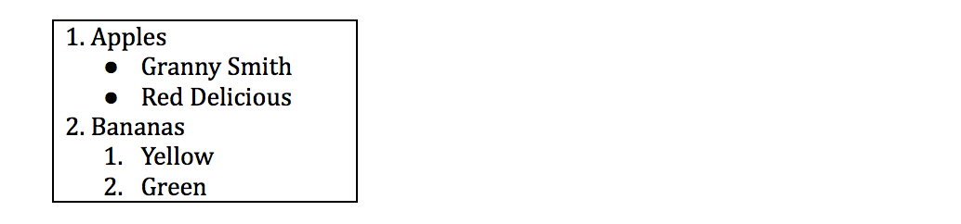

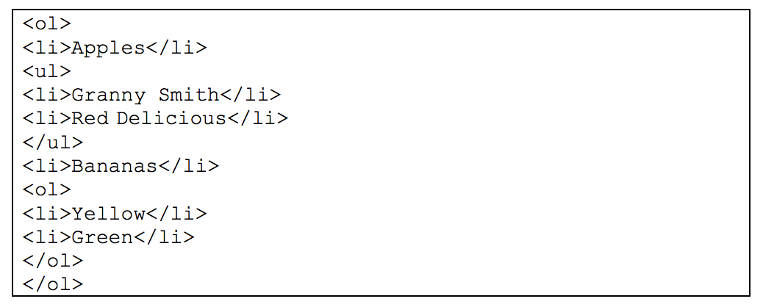

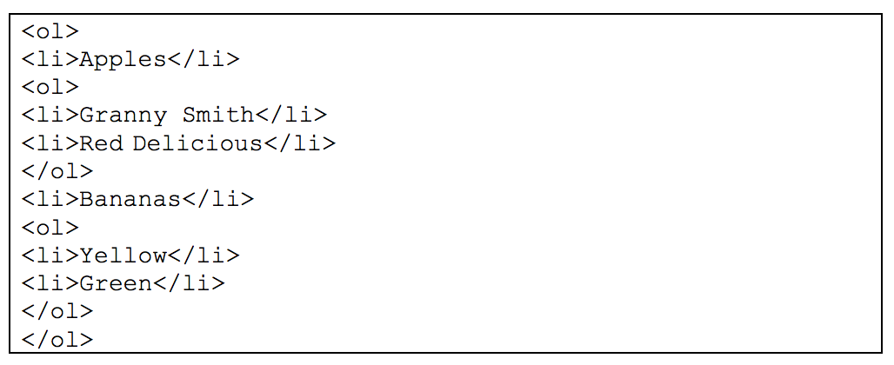

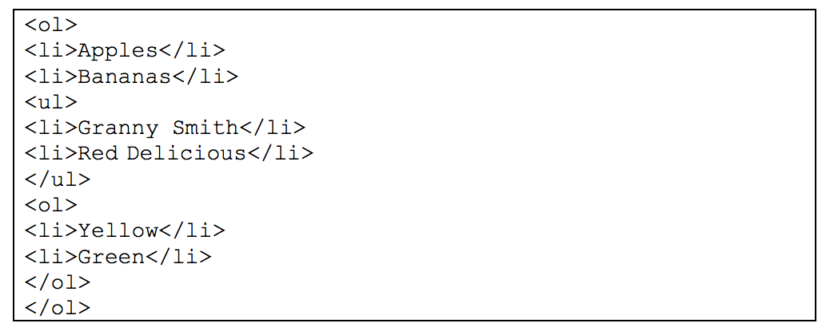

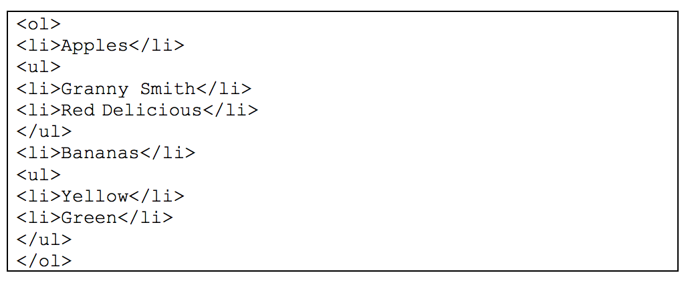

correct

**Answer : 1**

Correct!

The outer list is ordered. The list beneath “Apples” is unordered, and then the list beneath “Bananas” is ordered.

Submit

You have used 1 of 3 attemptsSome problems have options such as save, reset, hints, or show answer. These options follow the Submit button.

Hint SaveSave Your Answer Show Answer

Correct (1/1 point)

Review

Problem 2

1/1 point (graded)

In an HTML form, the difference between a radio button and a check box is that:

The user may choose only one option from a group of radio buttons, but may choose many options from a group of check boxes.

The user may choose only one option from a group of check boxes, but may choose many options from a group of radio buttons.

When a check box is selected, all other check boxes are unselected, but this is not the case with radio buttons.

The only difference is their appearance.

correct

**Answer : 1**

Correct:

Radio button elements are grouped using their “name” attribute and the user can only choose one value for that name.

**Quiz 1.8**

Quiz due Jul 27, 2020 20:05 +06

 Bookmark this page

Problem 1

1/1 point (graded)

The purpose of the “alt” attribute of an HTML “img” element is to:

Specify the text that should appear when the mouse hovers over the image.

Specify the text that the user should click to reveal the image.

Specify the text that should appear if the image does not load.

Specify the location of the image on the World Wide Web.

correct

**Answer : 3**

Correct:

The “title” attribute is used to show text when the mouse hovers over the image, but the “alt” attribute is used as the “alternative” to display.

Submit

You have used 1 of 3 attemptsSome problems have options such as save, reset, hints, or show answer. These options follow the Submit button.

Hint SaveSave Your Answer Show Answer

Correct (1/1 point)

Review

Problem 2

1/1 point (graded)

You are viewing a webpage at **http://www.example.com/fun/hello.html** and the HTML includes the element **<img src=”images/logo.jpg”>**, which uses a relative path to locate the image. The absolute path of that image would be:

http://www.example.com/images/logo.jpg

http://www.example.com/fun/hello.html/images/logo.jpg

http://www.example.com/fun/images/logo.jpg

images/logo.jpg

correct

**Answer : 3**

Correct:

The page hello.html is in the “fun/” directory. The relative path is relative to the location of the page, i.e. relative to the directory that it is in, so it would be in the “images/” subdirectory of “fun/”.

Submit

You have used 2 of 3 attemptsSome problems have options such as save, reset, hints, or show answer. These options follow the Submit button.

Hint SaveSave Your Answer Show Answer

Correct (1/1 point)

Review

Problem 3

1/1 point (graded)

What would be generated by the following HTML? 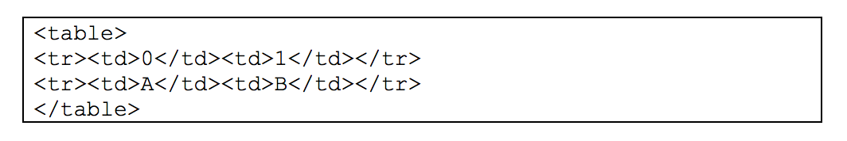

A table with two rows and two columns.

A table with one row and two columns.

A table with two rows and four columns.

A table with one row and one column.

correct

**Answer : 1**

Correct:

Each <tr> tag represents a new row in the table. Within the row, each <td> tag represents a new column.

**Quiz 1.9**

Quiz due Jul 27, 2020 20:05 +06

 Bookmark this page

Problem 1

1/1 point (graded)

The primary goal of Responsive Web Design is to:

Develop Web pages in such a way that they respond to the size of the device and browser when being rendered.

Develop Web pages in such a way that they respond to the actions of the user.

Allow for the inclusion of libraries that modify the appearance of the Web content.

Allow parts of Web pages to change while other parts stay the same.

correct

**Answer : 1**

Correct:

RWD is an approach to designing Web pages in a way that takes all devices into account.

Submit

You have used 1 of 3 attemptsSome problems have options such as save, reset, hints, or show answer. These options follow the Submit button.

Hint SaveSave Your Answer Show Answer

Correct (1/1 point)

Review

Problem 2

1/1 point (graded)

When organizing content using Bootstrap, we use:

<div> elements in the “container” and “row” classes.

<div> elements in the “table” and “tr” classes.

<table> and <tr> elements in the “container” classes.

<row> and <col> elements in the “container” classes.

correct

**Answer :1**

Correct:

The “container” <div> spans the width of the page and represents the area where the RWD content should reside. The “row” <div> represents the horizontal group of columns that hold the content.